Batch Processing

Checklists – Add Checklist

User Guide

The input file for Batch Checklists is an Excel spreadsheet, saved as a .csv file. The input file contains a Header row and a Column Headings row. The input rows follow.

Header row – Data is as follows:
Column A – will always be the value “HD”
Column B – Institution Code (IUBLA, IUINA, etc).
Column C – User’s Department
Column D – User’s Name
Column E – User’s Email Address

Column Headings row – description of column headings are shown in the Input Row section, along with their corresponding column.

Input rows – ALPHA DATA INPUT MUST BE IN ALL CAPITAL LETTERS WHERE INDICATED*. Required fields are in bold type. Use Screenshot 1 for visual reference.

Emplid (column A) – System ID

*Institution (column B) – campus identification, (IUBLA, IUINA, etc)

*Administration Function (column C) – Administrative Functions; valid values are ADMA, ADMP, AWRD, EVNT, FINA, PROS, SFAC, STRM, GEN & SPRG.

*Checklist Code (column D) – Code to assign Checklist; values will vary

*Checklist Status (column E) – valid values are I or C (Initiated or Completed)

Status Date (column F) – Date that Checklist is Completed or Initiated; will default to system date if no input provided.

Status Change ID (column G) – emplid of person assigning Checklist; will default to CHKLPRCS if no input provided.

Due Date (column H) – due date; will default to predefined date value in the CS Checklist Codes table for the institution and checklist code if no input provided

*Currency Code (column I) – value should always be USD

Due Amount (column J) – Amount due; will default to 0 if no input provided

*Department ID (column K) – Department ID; will default to blank if no input provided

Responsible ID (column L) – emplid of person responsible for Checklist; will default to same value as Status Change ID if no input provided

Tracking Sequence (column M) – Used in tracking groups; will default to 0 if no input provided.

Organization Contact (column N) – Used in billing external orgs; will default to blank if no input provided.

Contact Name (column O) – will default to blank if no input provided.

Checklist Comments (column P) – Comments field; will default to blank if no input provided.

Variable Data (columns Q – V) - This data will be the data specific to the Admin Function. The number of columns of variable data will depend on the value of the Admin Function. The variable data values for each Admin Function are as follows:

ADMA – ACAD CAREER, STDNT CAR NBR, ADM APPL NBR
ADMP – ACAD CAREER, STDNT CAR NBR, ADM APPL NBR, APPL PROG NBR
AWRD – AID YEAR, ACAD CAREER, ITEM TYPE
EVNT – CAMPUS EVENT NBR, EVENT MTG NBR
FINA – AID YEAR
GEN – No variable data for GEN
PROS – ACAD CAREER
SFAC – BUSINESS UNIT, ACCOUNT NBR, ACCOUNT TERM
SPRG – ACAD CAREER, STDNT CAR NBR
STRM – ACAD CAREER, STRM

Checklist Item assignment will default from the Checklist Table Control Table.

Screenshot 1
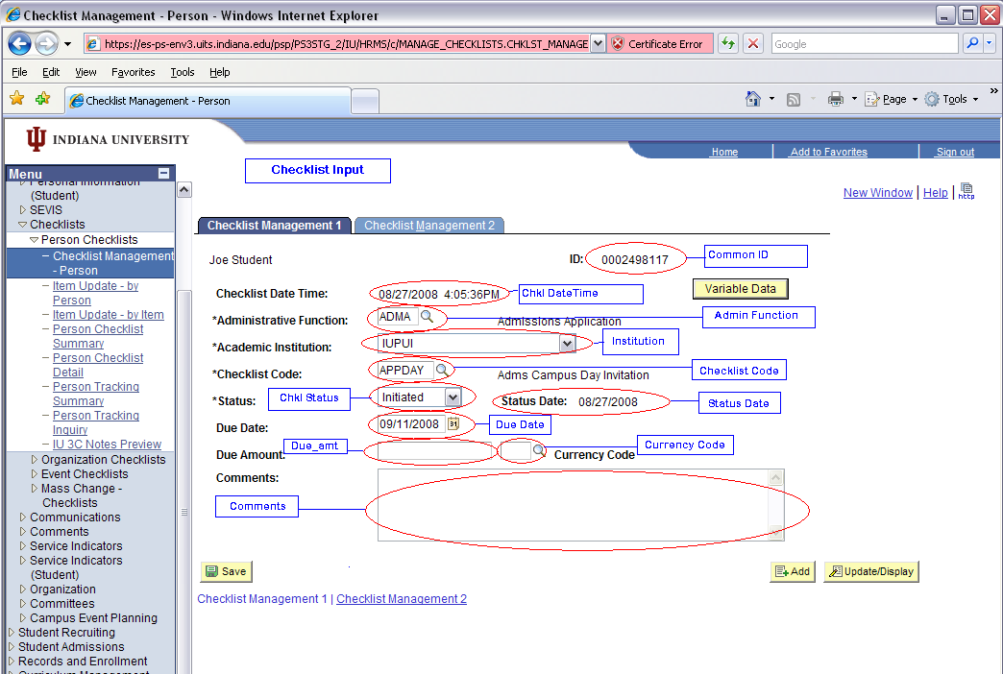

Screenshot 2 - Variable data for ADMA
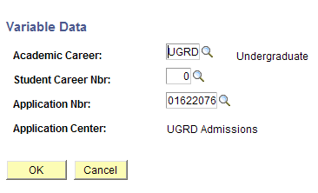

Example input file (all columns may not be included in this screen shot):

Save Files

User will save Excel file as a .csv file. Change ‘Save as type’ field to CSV (Comma delimited)(*.csv). Format for file name is iu3cload.chkl.*.csv. The wildcard (*) can be any descriptive text. Please do NOT include any spaces or special characters (underscores and periods are allowed).

You will also need a .recon file containing the total number of rows of input in the .csv file (including the 2 header rows). If you have 2 rows of actual input (as in the example shown above), and you have 2 header rows, then your .recon file should contain a value of 4. Include a hard return after the data (press the Enter key once). If the user doesn’t create a .recon file, the processor will need to do this before submitting the files to DTP.

Using Notepad, create the file.

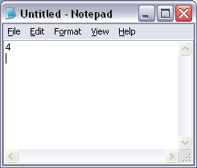

Change ‘Save as type’ to ‘All Files’. Save file as iu3cload.chkl.*.recon. The wildcard portion of the file name must match the wildcard portion on the .csv file.

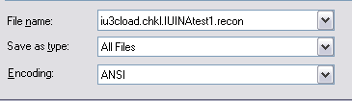

Drop Files to Folder

Drop .csv and .recon files into \\ADS\USSS\Campus_Community_Batch_Loads_RC\Batch_3Cs. Drop the files by 12 Noon to guarantee same-day processing. Any files dropped after 12 Noon may possibly not be processed until the following business day.

Questions
Send any questions to SES-BatchProcessing@exchange.iu.edu.

Mapping

You may need to map a new drive to \\ADS\USSS.

